一、基础篇

Hive的层次结构：
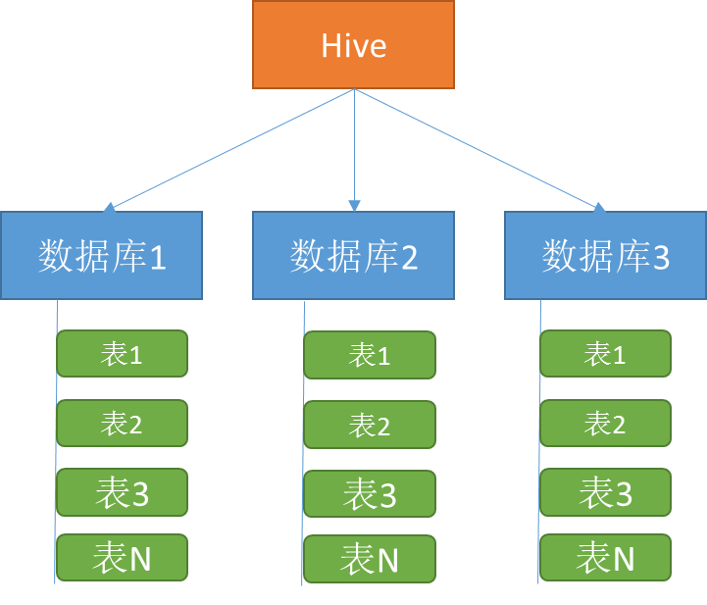

进入Hive
- 用自己的用户登陆网关机(172.16.213.223),运行命令hive,进入Hive Cli命令行：
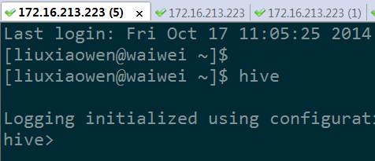
- 在Hive命令行运行 show databases; 查看所有的数据库
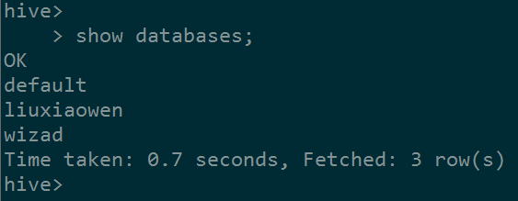

- 在Hive命令行运行 use database_name; 切换到自己业务的数据库；
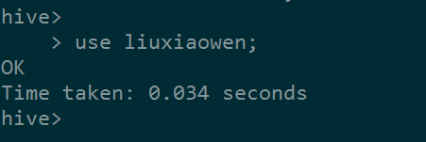

查看所有表
- 进入自己业务数据库后，在Hive命令行运行 show tables; 查看自己数据库中的所有表
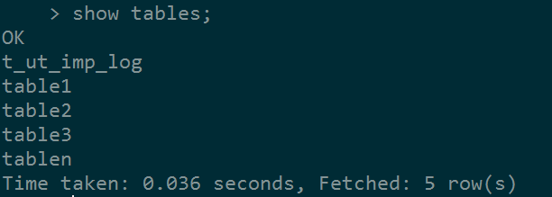

查看表结构
- desc table_name; 查看表的基础信息(字段、分区)
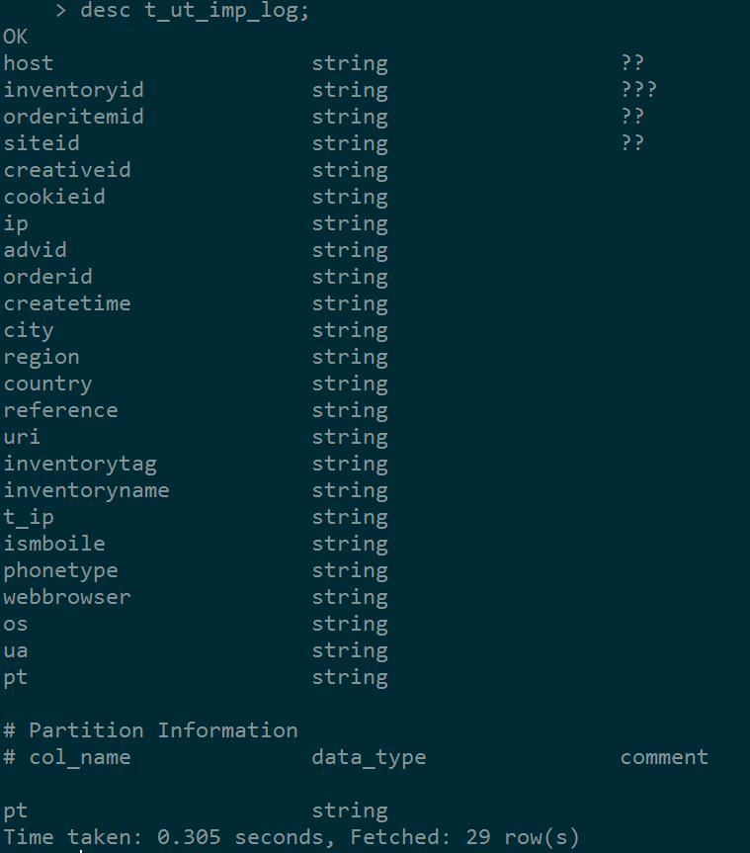

- desc formatted table_name; 查看表的详细信息(字段、分区、路径、格式等)
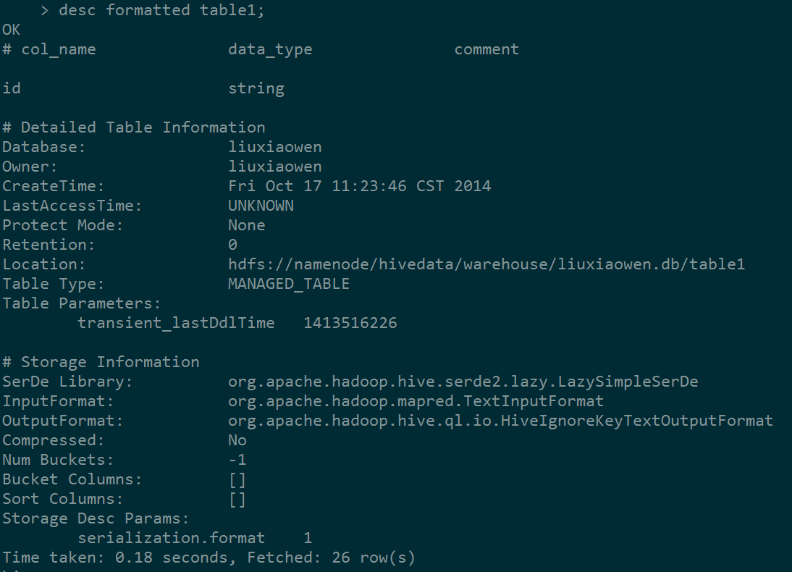

基本数据类型
整型：
TINYINT、SMALLINT、INT、BIGINT
布尔型：
BOOLEAN
浮点型：
FLOAT、DOUBLE
字符型：
STRING

https://cwiki.apache.org/confluence/display/Hive/Tutorial#Tutorial-TypeSystem

表

内部表和外部表的区别
内部表删除时候会删除Hadoop上的数据;
外部表删除时候不会删除Hadoop上的数据;

内部表
- 适用场景：中间表，结果表，不需要从外部（如本地文件、HDFS上load数据）
- 创建语法：
CREATE TABLE tab (
column1 STRING,
column2 STRING,
column3 STRING,
column4 STRING,
columnN STRING
);

外部表
- 适用场景：源表，需要将外部数据映射到表中
- 创建语法：
CREATE EXTERNAL TABLE tab (
column1 STRING,
column2 STRING,
column3 STRING,
column4 STRING,
columnN STRING
) ROW FORMAT DELIMITED
FIELDS TERMINATED BY '\t'
stored as textfile
location 'hdfs://namenode/tmp/liuxiaowen/tab/';

分区
- 对表按照一定的规则进行切分，如时间，每天（每小时）一个分区；
- 适用场景：数据量非常大，按照时间或其他属性周期性维护和查询；
- 创建分区语法：
CREATE TABLE tab (
column1 STRING,
columnN STRING
) partitioned BY (day STRING);
- 内部表和外部表都可以创建分区；
- 分区表必须在创建时候指定分区，对于一个已经创建好的非分区表，不能将其修改为分区表；
- 一个表可以有多个分区字段；
- 查看表有哪些分区：
show partitions table_name;
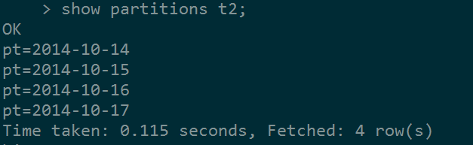
- 查看分区属性：
desc formatted t2 partition (pt = '2014-10-17');
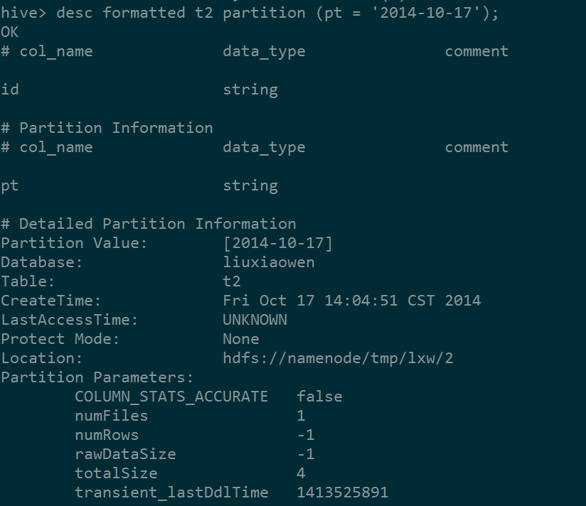
- 添加分区及数据：
ALTER TABLE tab ADD PARTITION (day = '2014-10-16')
location 'hdfs://namenode/tmp/liuxiaowen/tab/day=2014-10-16/';
ALTER TABLE tab ADD PARTITION (day = '2014-10-17')
location 'hdfs://namenode/tmp/liuxiaowen/tab/day=2014-10-17/';
- 删除一个分区：
ALTER TABLE tab DROP PARTITION (day = '2014-10-16');

修改表
- 重命名
ALTER TABLE old_table_name RENAME TO new_table_name;
- 添加字段
ALTER TABLE tab1 ADD COLUMNS (c1 INT, c2 STRING);

删除表
- DROP TABLE tab;

三、加载数据

3.1 将本地（windows）上的文件上传至网关机（linux）
以linux终端工具SecureCRT为例，登陆网关机，点击SecureFX按钮：
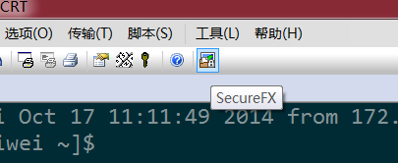

弹出文件传输框，左侧为本地，右侧为网关机；
选择左侧和右侧目录，将左侧本地文件拖至右侧区域即可完成文件上传。
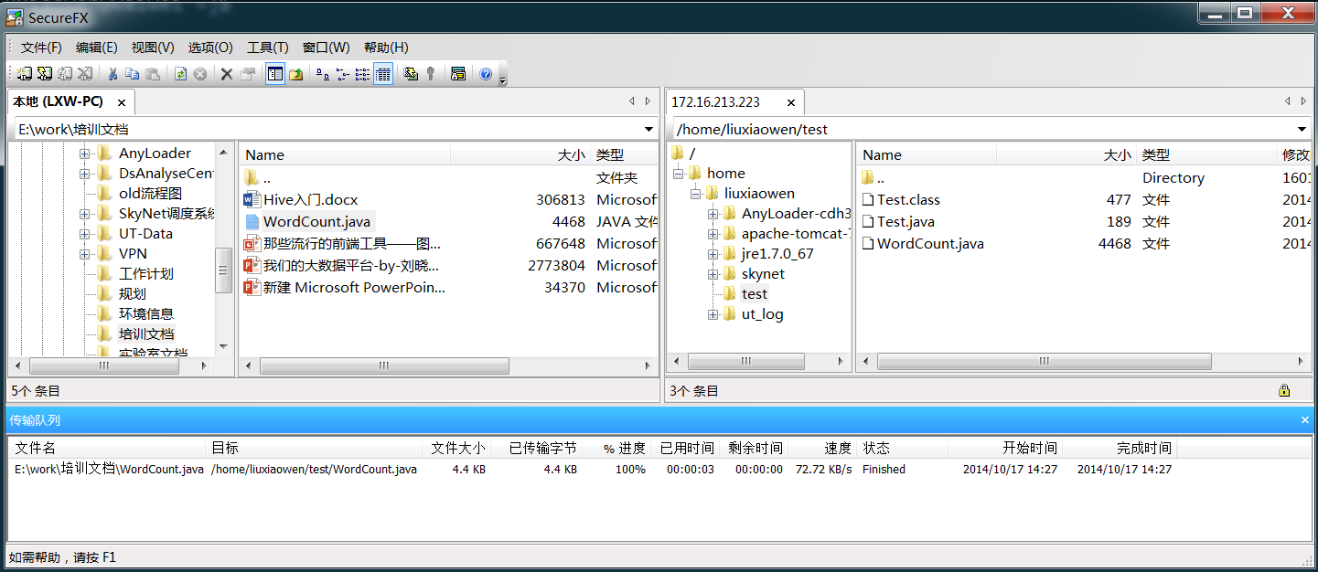

3.2 将网关机本地的文件上传至Hadoop
hadoop fs -put /tmp/f.txt /user/data/staging/page_view/

3.3 加载本地数据到外部表
- 创建时候指定location
CREATE EXTERNAL TABLE tab (
column1 STRING,
columnN STRING
) ROW FORMAT DELIMITED
FIELDS TERMINATED BY '\t'
stored as textfile
location 'hdfs://namenode/tmp/liuxiaowen/tab/';
- 将网关机本地文件上传至指定的location
hadoop fs -put /tmp/f.txt hdfs://namenode/tmp/liuxiaowen/tab/
- 文件格式要和表定义的格式一致

3.4 加载本地数据到内部表（分区）
- 加载网关机本地文件到内部表
LOAD DATA LOCAL INPATH /tmp/f.txt INTO TABLE tab PARTITION (day = ‘2014-10-17’);
LOAD DATA LOCAL INPATH /tmp/f.txt OVERWRITE INTO TABLE tab PARTITION (day = ‘2014-10-17’);
* INTO 为追加，OVERWRITE INTO 为覆盖
- 加载Hadoop文件到内部表
LOAD DATA INPATH '/tmp/liuxiaowen/tab/f.txt' INTO TABLE tab PARTITION (day = ‘2014-10-17’);
LOAD DATA INPATH '/tmp/liuxiaowen/tab/f.txt' OVERWRITE INTO TABLE tab PARTITION (day = ‘2014-10-17’);
* LOAD DATA LOCAL INPATH 为网关机本地路径，LOAD DATA INPATH为Hadoop路径
- 文件格式要和表定义的格式一致

3.5 从一个查询结果集加载数据（INSERT）
INSERT INTO TABLE tab PARTITION (day = ‘2014-10-17’)
SELECT * FROM source_table;
INSERT OVERWRITE TABLE tab PARTITION (day = ‘2014-10-17’)
SELECT * FROM source_table;

- INTO 为追加，OVERWRITE为覆盖

四、下载数据

4.1 从Hadoop上下载文件到本地
hadoop fs –get /hivedata/warehouse/liuxiaowen/1.txt /home/liuxiaowen/data/

4.2 将一个查询结果集保存到本地文件
INSERT OVERWRITE LOCAL DIRECTORY '/home/liuxiaowen/data/'
ROW FORMAT DELIMITED FIELDS TERMINATED BY ','
SELECT * FROM source_table;

五、查询

5.1 简单查询
SELECT *
FROM user
WHERE userid = ‘u1’;

SELECT u.userid,u.age,u.sex
FROM user u
WHERE userid = ‘u2’;

5.2 基于分区的查询
SELECT *
FROM user
WHERE userid = ‘u1’ AND day = ‘2014-10-17’;

SELECT u.userid,u.age,u.sex
FROM user u
WHERE userid = ‘u2’ AND u.day >= ‘2014-10-16’ AND u.day <= ‘2014-10-17’

5.3 关联查询(JOIN)
用户表：
userid | age | sex
u1 | 29 | f
u2 | 25 | m
u3 | 24 | m
u4 | 30 | f

PV表：

userid | pv | day
u1 | 13 | 2014-10-17
u2 | 15 | 2014-10-17
u1 | 15 | 2014-10-16
u3 | 16 | 2014-10-16
u4 | 20 | 2014-10-16

SELECT u.userid,u.age,u.sex,p.pv
FROM user u JOIN pv p
ON (u.userid = p.userid)
WHERE p.day = '2014-10-17';

userid | age | sex | pv
u1 | 29 | f | 13
u2 | 25 | m | 15

SELECT u.userid,u.age,u.sex,p.pv
FROM user u LEFT OUTER JOIN pv p
ON (u.userid = p.userid AND p.day = '2014-10-17');

userid | age | sex | pv
u1 | 29 | f | 13
u2 | 25 | m | 15
u3 | 24 | m | NULL
u4 | 30 | f | NULL

SELECT u.userid,u.age,u.sex,IF(p.pv IS NULL,0,p.pv)
FROM user u LEFT OUTER JOIN pv p
ON (u.userid = p.userid AND p.day = '2014-10-17');

userid | age | sex | pv
u1 | 29 | f | 13
u2 | 25 | m | 15
u3 | 24 | m | 0
u4 | 30 | f | 0

5.4 聚合汇总
- 查询用户一段时间内的总PV：

SELECT userid,
SUM(pv)
FROM pv
WHERE day >= '2014-10-16' AND day <= '2014-10-17'
GROUP BY userid;
---------------------------------------------
u1 28
u2 15
u3 16
u4 20
- 查询每一天的总PV
SELECT day,
SUM(pv)
FROM pv
GROUP BY day;
---------------------------------------------
2014-10-16 51
2014-10-17 28

https://cwiki.apache.org/confluence/display/Hive/Tutorial#Tutorial-UsageandExamples

5.5 基于函数的复杂查询
- 域名解析：
SELECT
a.t_ip,
regexp_extract(t_ip,'//(.*?)/',1),
parse_url(t_ip,'HOST')
FROM t_ut_imp_log a
WHERE a.pt = '2014-09-01'
AND t_ip LIKE 'http://%'
limit 10;
---------------------------------------------
http://v.admaster.com.cn/i/a21771,b200492904,c3527,i0,m202,h v.admaster.com.cn v.admaster.com.cn
http://imp.gentags.net/imp/iv-5175/st-47/oi-183866/cr-2/adv-9/or-3271/pcon-0/ imp.gentags.net imp.gentags.net
http://v.admaster.com.cn/i/a21771,b200492904,c3527,i0,m202,h v.admaster.com.cn v.admaster.com.cn
http://imp.gentags.net/imp/iv-4496/st-47/oi-183837/cr-2/adv-9/or-3271/pcon-0/ imp.gentags.net imp.gentags.net

- 访问路径、页面停留时间、是否新的SESSION
SELECT
cookieid,
SUM(1) OVER(PARTITION BY cookieid) AS pv,
ROW_NUMBER() OVER(PARTITION BY cookieid ORDER BY createtime) AS depth,
createtime,
LAG(createtime) OVER(PARTITION BY cookieid ORDER BY createtime) AS last_view_time,
LEAD(createtime) OVER(PARTITION BY cookieid ORDER BY createtime) AS next_view_time,
uri,
FIRST_VALUE(uri) OVER(PARTITION BY cookieid ORDER BY createtime) AS landing_page
FROM t_ut_imp_log
WHERE pt = '2014-09-01'
AND cookieid = '24D7776A00023753F1ACB9'
ORDER BY createtime;

---------------------------------------------
结果见前面的tab.xlsx

附录A

A.1 Hive基础教程
https://cwiki.apache.org/confluence/display/Hive/Tutorial

A.2 Hive操作和函数
https://cwiki.apache.org/confluence/display/Hive/LanguageManual+UDF

A.3 Hive DDL语法
DDL：数据定义语言。
创建、修改、删除（数据库、表、分区、列、视图、索引等数据库对象）。
https://cwiki.apache.org/confluence/display/Hive/LanguageManual+DDL

A.4 Hive查询语法
https://cwiki.apache.org/confluence/display/Hive/LanguageManual+Select

A.5 Hive命令行使用说明
https://cwiki.apache.org/confluence/display/Hive/LanguageManual+Cli

